**PRAKTIKUM ALGORITMA DAN STRUKTUR DATA**

**KUIS 1**



**NAMA : DIMAS ADI BAYU SAMUDRA**

**KELAS : 1A**

**NO. ABSEN : 08**

**NIM : 2341720169**

**PROGRAM STUDI TEKNIK INFORMATIKA**

**JURUSAN TEKNOLOGI INFORMASI**

**POLITEKNIK NEGERI MALANG**

**2024**

**KUIS 1**

**PRAKTIKUM ALGORITMA DAN STRUKTUR DATA**

1. Pada Sistem Persewaan terdapat class sesuai jenis barang yang disewakan, tentukan barang yang disewakan, bebas. Rancanglah class diagram barang tersebut, dengan jumlah atribut dan method masing-masing minimal 3. Buatlah program untuk mengimplementasikan class tersebut, menginputkan data atribut menggunakan konstruktor, menampilkan data, mengolah/menghitung method dan menampilkan hasil perhitungan/pengolahan.

**Code kamera**

|  |
| --- |
| package kuis1;  public class kamera {  int id_kamera;  String merek;  String jenis;  int harga_sewa;  String resolusi;  String status;  double diskon;  public kamera(int id_kamera, String merek, String jenis, int harga_sewa, String resolusi, String status) {  this.id_kamera = id_kamera;  this.merek = merek;  this.jenis = jenis;  this.harga_sewa = harga_sewa;  this.resolusi = resolusi;  this.status = status;  }  public void setStatus(String status) {  this.status = status;  }  public int hitungBiayaSewa(int durasiSewa) {  harga_sewa = harga_sewa * durasiSewa;  return harga_sewa;  }  int hitungDiskon() {  if (harga_sewa > 1000000) {  diskon = harga_sewa * 0.80;  } else if (harga_sewa >= 800000 || harga_sewa <= 600000){  diskon = harga_sewa * 0.95;  } else if(harga_sewa <= 400000){  System.out.println("Tidak ada diskon ");  }  System.out.println("Hitung harga setelah di diskon : " + diskon);  return (int) diskon;  }  int hargaBayar(){  int hargaBayar = (int) diskon;  System.out.println("Harga yang harus di bayar : " + hargaBayar);  return hargaBayar;  }  public void tampilkanInfo() {  System.out.println("ID Kamera: " + id_kamera);  System.out.println("Merek: " + merek);  System.out.println("Jenis: " + jenis);  System.out.println("Harga Sewa: Rp" + harga_sewa);  System.out.println("Resolusi: " + resolusi);  System.out.println("Status: " + status);  }  } |

**Kode main kamera**

|  |
| --- |
| package kuis1;  import java.util.Scanner;  public class mainKamera {  public static void main(String[] args) {  Scanner sc = new Scanner(System.in);  System.out.println("=======================================");  System.out.println("=======================================");  System.out.print("Masukkan ID Kamera: ");  int idKamera = sc.nextInt();  System.out.print("Masukkan Merek: ");  String merek = sc.next();  System.out.print("Masukkan Jenis: ");  String jenis = sc.next();  System.out.print("Masukkan Resolusi: ");  String resolusi = sc.next();  System.out.print("Masukkan Harga Sewa: ");  int hargaSewa = sc.nextInt();  kamera kamera1 = new kamera(idKamera, merek, jenis, hargaSewa, resolusi, "tersedia");  System.out.println("=======================================");  System.out.println("=======================================");  kamera1.tampilkanInfo();  System.out.println("=======================================");  System.out.println("BIAYA KAMERA YANG DI SEWA");  System.out.println("=======================================");    System.out.println("Biaya sewa untuk 3 hari: Rp" + kamera1.hitungBiayaSewa(3));  kamera1.setStatus("disewa");    System.out.println("=======================================");  System.out.println("DETAIL KAMERA YANG DI SEWA");  System.out.println("=======================================");  kamera1.tampilkanInfo();  int diskon = kamera1.hitungDiskon();  System.out.println("Diskon: Rp" + diskon);  int hargaBayar = kamera1.hargaBayar();  System.out.print("Harga yang harus dibayar: Rp" + hargaBayar);  }  } |

**Hasil run**

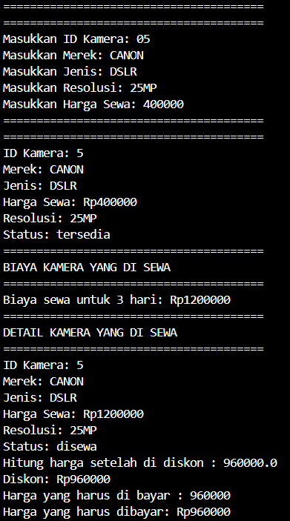

**Class Diagram**

|  |  |
| --- | --- |
| Class | kamera |
| Atribut | * int id_kamera; * String merek; * String jenis; * int harga_sewa; * String resolusi; * String status; * double diskon; |
| Method | * void setStatus(String status); * int hitungBiayaSewa(int durasiSewa); * int hitungDiskon(); * int hargaBayar(); * void tampilkanInfo() |

|  |  |
| --- | --- |
| Class | mainKamera |
| Atribut | * int id_kamera; * String merek; * String jenis; * int harga_sewa; * String resolusi; * String status |
| Method | * Main (); |